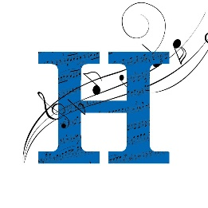

HIGHLANDS BAND ASSOCIATION

2400 Memorial Parkway   
Fort Thomas KY 41075

The Fort Thomas Independent Schools are proud to have students participating in band in grades 5-12. Students have the opportunity to perform in marching band, jazz band, pep band, color guard, and percussion ensemble. The Highlands Band Booster Association was created to nurture and support these fine musicians. Periodically the association performs fundraisers to financially support the musical needs of these students. Over the years, the association has used fundraising profits to provide music, instruments, transportation, and instruction to these aspiring musicians.

We are currently working on a Scrapbooking fundraiser that will be held on December 6th-7th. We need support from the community and local businesses. There are many ways you could help. We will need donations of items and gift cards to aid in the raffles, prizes, and auctions we will have at the event. Monetary donations are always extremely helpful. Your donation is tax deductible (tax id: 010551398).

We believe that music enriches the lives of these students and those around them. Please consider supporting our band program in any way you can. You can contact us via email at [fun4dixie@gmail.com](mailto:fun4dixie@gmail.com) / [tierney03@yahoo.com](mailto:tierney03@yahoo.com) or at the phone numbers below.

Thank you,

Laura Mester and Tonya Tierney

859-250-8424 859-916-0030

Co-chairs of Holiday Scrappin’ at Highlands